References:

1. Most commonly used drugs in surgery

<https://www.verywell.com/drugs-used-before-during-and-after-surgery-3156830>

### [Antibiotics](https://www.verywell.com/antibiotics-before-and-after-surgery-3157300):

* Amoxicillin
* Ampicillin
* Ancef (Cefazolin)
* Keflex (Cephalexin)
* Levaquin (Levofloxacin)
* Linezolid
* Maxipime (Cefepime)
* Piperacillin
* Rifampin
* Rocephin (Ceftriaxone)
* Vancomycin

1. Vitals to check after surgery

<https://www.nursingtimes.net/download?ac=1265633>

6 physiological parameters to check developed by NEWS (The National Early Warning Score):

Respiratory Rate, Oxygen saturation, Temperature, Systolic blood pressure, Pulse Rate, Level of consciousness

NEWS: <https://www.rcplondon.ac.uk/projects/outputs/national-early-warning-score-news>

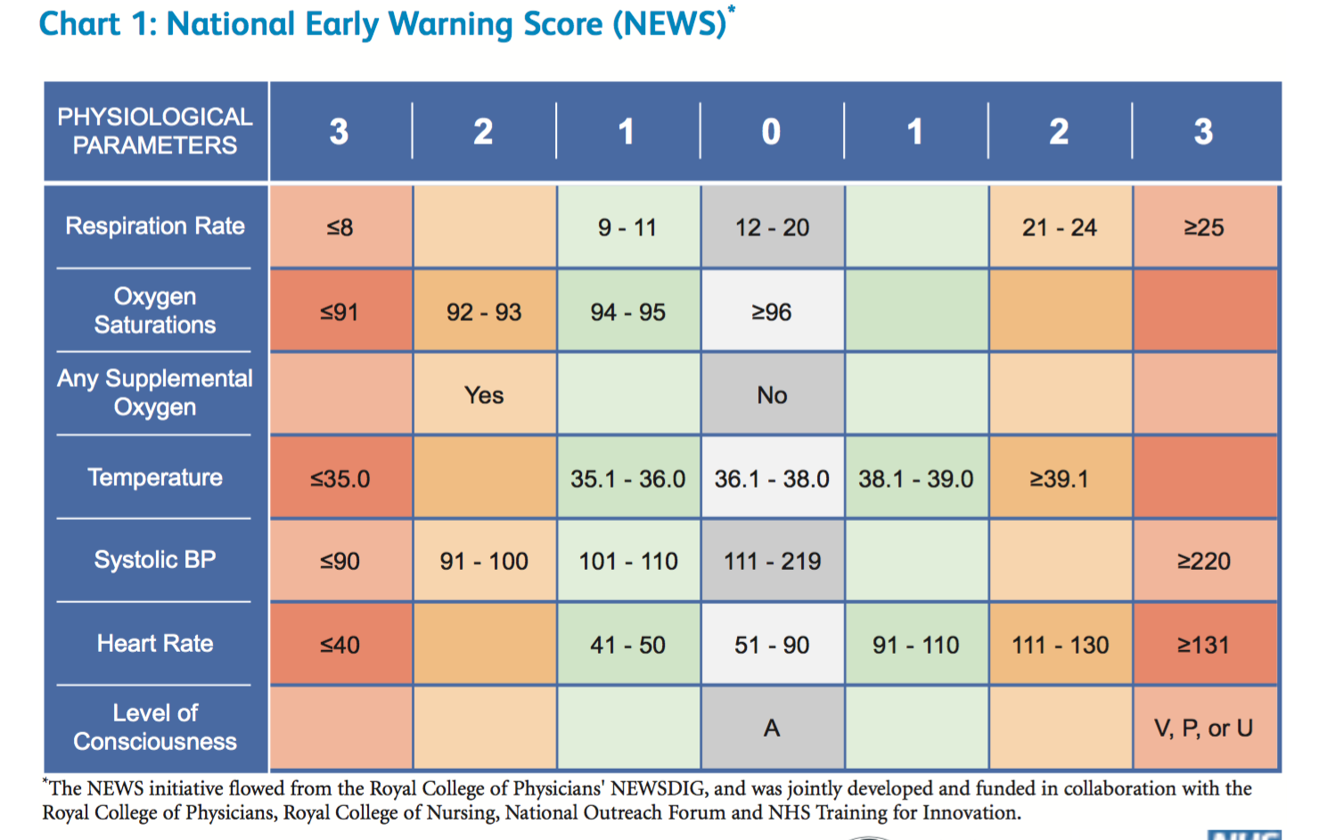

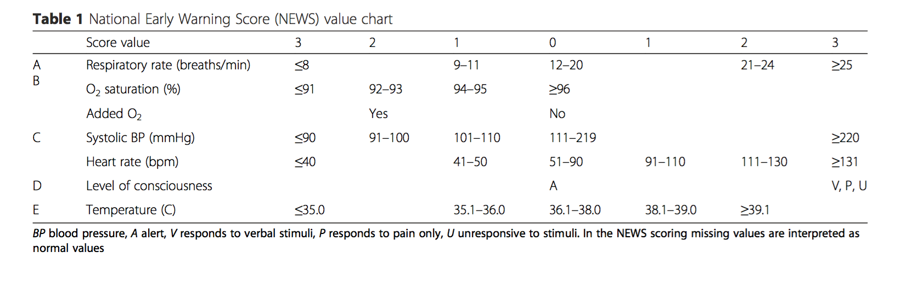

Notes: Supplemental Oxygen is not included, since one patient can have multiple chart events, which means he/she can have supplemental oxygen set in some records but not in others.

Temperature in F is used, since there are more such records than Temperature in C and many records of Temp in C are incorrectly collected (by manually examination).

Level of consciousness is not included in analysis, for the same reason of excluding supplemental oxygen.

1. ICD-9 Diagnosis

<http://www.tdrdata.com/ipd/ipd_SearchForICD9CodesAndDescriptions>

|  |  |
| --- | --- |
| [001 - 139](IPD_SearchForICD9CodesAndDescriptionsData.aspx?SearchCriteria1=001.&SearchCriteria2=140.&Precision=4&Title=Infectious%20and%20Parasitic%20Diseases) | [Infectious and Parasitic Diseases](IPD_SearchForICD9CodesAndDescriptionsData.aspx?SearchCriteria1=001.&SearchCriteria2=140.&Precision=4&Title=Infectious%20and%20Parasitic%20Diseases) |
| [140 - 239](http://www.tdrdata.com/ipd/IPD_SearchForICD9CodesAndDescriptionsData.aspx?SearchCriteria1=140.&SearchCriteria2=240.&Precision=4&Title=Neoplasms) | [Neoplasms](http://www.tdrdata.com/ipd/IPD_SearchForICD9CodesAndDescriptionsData.aspx?SearchCriteria1=140.&SearchCriteria2=240.&Precision=4&Title=Neoplasms) |
| [240 - 279](IPD_SearchForICD9CodesAndDescriptionsData.aspx?SearchCriteria1=240.&SearchCriteria2=280.&Precision=4&Title=Endocrine,%20Nutritional,%20Metabolic,%20Immunity) | [Endocrine, Nutritional, Metabolic, Immunity](IPD_SearchForICD9CodesAndDescriptionsData.aspx?SearchCriteria1=240.&SearchCriteria2=280.&Precision=4&Title=Endocrine,%20Nutritional,%20Metabolic,%20Immunity) |
| [280 - 289](IPD_SearchForICD9CodesAndDescriptionsData.aspx?SearchCriteria1=280.&SearchCriteria2=290.&Precision=4&Title=Blood%20and%20Blood-Forming%20Organs) | [Blood and Blood-Forming Organs](IPD_SearchForICD9CodesAndDescriptionsData.aspx?SearchCriteria1=280.&SearchCriteria2=290.&Precision=4&Title=Blood%20and%20Blood-Forming%20Organs) |
| [290 - 319](IPD_SearchForICD9CodesAndDescriptionsData.aspx?SearchCriteria1=290.&SearchCriteria2=320.&Precision=4&Title=Mental%20Disorders) | [Mental Disorders](IPD_SearchForICD9CodesAndDescriptionsData.aspx?SearchCriteria1=290.&SearchCriteria2=320.&Precision=4&Title=Mental%20Disorders) |
| [320 - 389](IPD_SearchForICD9CodesAndDescriptionsData.aspx?SearchCriteria1=320.&SearchCriteria2=390.&Precision=4&Title=Nervous%20System%20and%20Sense%20Organs) | [Nervous System and Sense Organs](IPD_SearchForICD9CodesAndDescriptionsData.aspx?SearchCriteria1=320.&SearchCriteria2=390.&Precision=4&Title=Nervous%20System%20and%20Sense%20Organs) |
| [390 - 459](IPD_SearchForICD9CodesAndDescriptionsData.aspx?SearchCriteria1=390.&SearchCriteria2=460.&Precision=4&Title=Circulatory%20System) | [Circulatory System](IPD_SearchForICD9CodesAndDescriptionsData.aspx?SearchCriteria1=390.&SearchCriteria2=460.&Precision=4&Title=Circulatory%20System) |
| [460 - 519](IPD_SearchForICD9CodesAndDescriptionsData.aspx?SearchCriteria1=460.&SearchCriteria2=520.&Precision=4&Title=Respiratory%20System) | [Respiratory System](IPD_SearchForICD9CodesAndDescriptionsData.aspx?SearchCriteria1=460.&SearchCriteria2=520.&Precision=4&Title=Respiratory%20System) |
| [520 - 579](IPD_SearchForICD9CodesAndDescriptionsData.aspx?SearchCriteria1=520.&SearchCriteria2=580.&Precision=4&Title=Digestive%20System) | [Digestive System](IPD_SearchForICD9CodesAndDescriptionsData.aspx?SearchCriteria1=520.&SearchCriteria2=580.&Precision=4&Title=Digestive%20System) |
| [580 - 629](IPD_SearchForICD9CodesAndDescriptionsData.aspx?SearchCriteria1=580.&SearchCriteria2=630.&Precision=4&Title=Genitourinary%20System) | [Genitourinary System](IPD_SearchForICD9CodesAndDescriptionsData.aspx?SearchCriteria1=580.&SearchCriteria2=630.&Precision=4&Title=Genitourinary%20System) |
| [630 - 677](IPD_SearchForICD9CodesAndDescriptionsData.aspx?SearchCriteria1=630.&SearchCriteria2=678.&Precision=4&Title=Pregnancy,%20Childbirth,%20and%20the%20Puerperium) | [Pregnancy, Childbirth, and the Puerperium](IPD_SearchForICD9CodesAndDescriptionsData.aspx?SearchCriteria1=630.&SearchCriteria2=678.&Precision=4&Title=Pregnancy,%20Childbirth,%20and%20the%20Puerperium) |
| [680 - 709](IPD_SearchForICD9CodesAndDescriptionsData.aspx?SearchCriteria1=680.&SearchCriteria2=710.&Precision=4&Title=Skin%20and%20Subcutaneous%20Tissue) | [Skin and Subcutaneous Tissue](IPD_SearchForICD9CodesAndDescriptionsData.aspx?SearchCriteria1=680.&SearchCriteria2=710.&Precision=4&Title=Skin%20and%20Subcutaneous%20Tissue) |
| [710 - 739](IPD_SearchForICD9CodesAndDescriptionsData.aspx?SearchCriteria1=710.&SearchCriteria2=740.&Precision=4&Title=Musculoskeletal%20System%20and%20Connective%20Tissue) | [Musculoskeletal System and Connective Tissue](IPD_SearchForICD9CodesAndDescriptionsData.aspx?SearchCriteria1=710.&SearchCriteria2=740.&Precision=4&Title=Musculoskeletal%20System%20and%20Connective%20Tissue) |
| [740 - 759](IPD_SearchForICD9CodesAndDescriptionsData.aspx?SearchCriteria1=740.&SearchCriteria2=760.&Precision=4&Title=Congenital%20Anomalies) | [Congenital Anomalies](IPD_SearchForICD9CodesAndDescriptionsData.aspx?SearchCriteria1=740.&SearchCriteria2=760.&Precision=4&Title=Congenital%20Anomalies) |
| [760 - 779](IPD_SearchForICD9CodesAndDescriptionsData.aspx?SearchCriteria1=760.&SearchCriteria2=780.&Precision=4&Title=Conditions%20Originating%20in%20the%20Perinatal%20Period) | [Conditions Originating in the Perinatal Period](IPD_SearchForICD9CodesAndDescriptionsData.aspx?SearchCriteria1=760.&SearchCriteria2=780.&Precision=4&Title=Conditions%20Originating%20in%20the%20Perinatal%20Period) |
| [780 - 789](http://www.tdrdata.com/ipd/IPD_SearchForICD9CodesAndDescriptionsData.aspx?SearchCriteria1=780.&SearchCriteria2=790.&Precision=4&Title=Symptoms) | [Symptoms](http://www.tdrdata.com/ipd/IPD_SearchForICD9CodesAndDescriptionsData.aspx?SearchCriteria1=780.&SearchCriteria2=790.&Precision=4&Title=Symptoms) |
| [790 - 796](IPD_SearchForICD9CodesAndDescriptionsData.aspx?SearchCriteria1=790.&SearchCriteria2=797.&Precision=4&Title=Nonspecific%20Abnormal%20Findings) | [Nonspecific Abnormal Findings](IPD_SearchForICD9CodesAndDescriptionsData.aspx?SearchCriteria1=790.&SearchCriteria2=797.&Precision=4&Title=Nonspecific%20Abnormal%20Findings) |
| [797 - 799](IPD_SearchForICD9CodesAndDescriptionsData.aspx?SearchCriteria1=797.&SearchCriteria2=800.&Precision=4&Title=Ill-defined%20and%20Unknown%20Causes%20of%20Morbidity%20and%20Mortality) | [Ill-defined and Unknown Causes of Morbidity and Mortality](IPD_SearchForICD9CodesAndDescriptionsData.aspx?SearchCriteria1=797.&SearchCriteria2=800.&Precision=4&Title=Ill-defined%20and%20Unknown%20Causes%20of%20Morbidity%20and%20Mortality) |
| [800 - 999](IPD_SearchForICD9CodesAndDescriptionsData.aspx?SearchCriteria1=800.&SearchCriteria2=999.999&Precision=4&Title=Injury%20and%20Poisoning) | [Injury and Poisoning](IPD_SearchForICD9CodesAndDescriptionsData.aspx?SearchCriteria1=800.&SearchCriteria2=999.999&Precision=4&Title=Injury%20and%20Poisoning) |
| [V Codes](IPD_SearchForICD9CodesAndDescriptionsData.aspx?SearchCriteria1=V&SearchCriteria2=V&Precision=0&Title=V%20Codes&Title=Reference%20Codes) | [Supplemental V-Codes](IPD_SearchForICD9CodesAndDescriptionsData.aspx?SearchCriteria1=V&SearchCriteria2=V&Precision=0&Title=V%20Codes&Title=Reference%20Codes) |
| [Ref Codes](IPD_SearchForICD9CodesAndDescriptionsData.aspx?SearchCriteria1=REF&SearchCriteria2=REF&Precision=0&Title=Reference%20Codes&Title=Reference%20Codes) | [Reference Codes](IPD_SearchForICD9CodesAndDescriptionsData.aspx?SearchCriteria1=REF&SearchCriteria2=REF&Precision=0&Title=Reference%20Codes&Title=Reference%20Codes) |

Patients with V codes are dropped because they are unable to be categorized.